**The Benefits of Hiring a Hacker: Strengthening Your iPhone's Security**

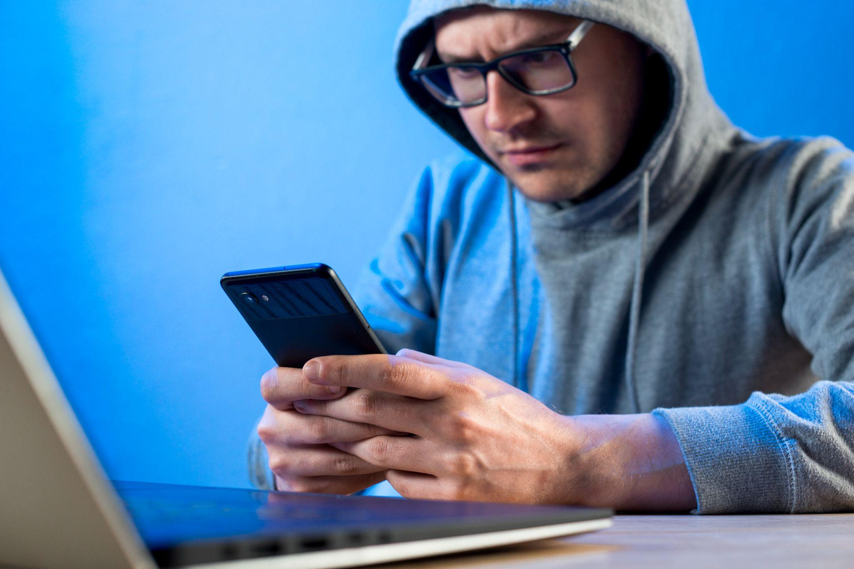

In an era where digital security is paramount, the notion of hiring a hacker might seem counterintuitive. However, engaging cybersecurity services, particularly those specializing in iPhone security, can provide significant advantages. This article explores the multifaceted benefits of [hiring a hacker for iphone](https://thenoblehackers.com/iphone-hacking-services/) to enhance your iPhone's security, addressing common vulnerabilities and offering practical solutions.

#### Understanding Cybersecurity Services

Cybersecurity services encompass a range of practices designed to protect systems, networks, and data from cyber threats. These services are essential for individuals and businesses alike, particularly as cyberattacks become increasingly sophisticated. By hiring a hacker—often referred to as an ethical hacker or penetration tester—you can gain valuable insights into potential vulnerabilities in your iPhone's security.

#### The Role of Ethical Hackers

Ethical hackers are cybersecurity professionals who use their skills to identify and fix vulnerabilities in systems. Unlike malicious hackers, ethical hackers operate with permission and aim to improve security rather than exploit weaknesses. Their expertise can be particularly beneficial for iPhone users who may not be aware of the various threats that exist.

#### Common Threats to iPhone Security

1. Malware and Phishing Attacks: Despite iPhones being generally secure, they are not immune to malware or phishing attempts. Attackers often use deceptive emails or messages to trick users into revealing personal information.
2. Public Wi-Fi Vulnerabilities: Using public Wi-Fi networks can expose your device to man-in-the-middle attacks, where hackers intercept data transmitted over the network.
3. Outdated Software: Failing to regularly update your iPhone can leave it vulnerable to known exploits. Hackers can easily take advantage of outdated software to gain unauthorized access.
4. Weak Passwords: Many users still employ weak passwords or reuse them across multiple accounts, making it easier for attackers to compromise their devices.

#### Benefits of Hiring a Hacker for Your iPhone

#### 1. Comprehensive Security Assessments

Hiring a hacker allows you to conduct a thorough security assessment of your iPhone. Ethical hackers can simulate attacks to identify vulnerabilities that you may not have recognized. This proactive approach helps in fortifying your device against potential threats.

#### 2. Customized Security Solutions

Once vulnerabilities are identified, ethical hackers can recommend tailored solutions that fit your specific needs. This might include setting up robust password policies, enabling two-factor authentication, or configuring advanced security features available on your iPhone.

#### 3. Awareness and Training

An often-overlooked aspect of cybersecurity is user awareness. Ethical hackers can provide training sessions that educate users about common cyber threats and best practices for maintaining device security. This knowledge empowers users to make informed decisions regarding their digital safety.

#### 4. Incident Response Planning

In the unfortunate event of a security breach, having a plan in place is crucial. Ethical hackers can help you develop an incident response strategy that outlines steps to take if your device is compromised. This includes identifying the breach, containing the damage, and recovering lost data.

#### 5. Ongoing Support and Monitoring

Cybersecurity is not a one-time effort; it requires continuous monitoring and updates. By hiring [cybersecurity services](http://thenoblehackers.com/), you gain access to ongoing support that helps keep your device secure against emerging threats.

#### Real-World Examples of Cybersecurity Breaches

The increasing frequency of cyberattacks highlights the importance of robust security measures:

* High-Profile Data Breaches: Major corporations have suffered significant breaches due to inadequate security measures, resulting in the exposure of sensitive customer data.
* Ransomware Attacks: Many organizations have faced ransomware attacks where hackers encrypt data and demand payment for its release. These incidents underscore the need for effective cybersecurity strategies.

#### How to Hire an Ethical Hacker

When considering hiring an ethical hacker or cybersecurity service for your iPhone, follow these guidelines:

1. Research Credentials: Look for certified professionals with experience in mobile device security.
2. Check Reviews and References: Seek feedback from previous clients to gauge the effectiveness and reliability of their services.
3. Discuss Your Needs: Clearly outline your specific concerns and requirements during initial consultations.
4. Understand Pricing Models: Be aware of how they charge—whether it's a flat fee or based on hourly rates—and ensure it aligns with your budget.

#### Conclusion

In conclusion, hiring a hacker as part of your cybersecurity strategy can significantly enhance your iPhone's security posture. By leveraging the expertise of ethical hackers through cybersecurity services, you can proactively identify vulnerabilities, implement effective solutions, and stay informed about evolving threats. As cybercrime continues to rise, investing in professional assistance is not just wise; it's essential for safeguarding your digital life.

By recognizing the value that ethical hacking brings to personal and organizational security, you empower yourself against potential cyber threats while ensuring that your personal information remains protected in an increasingly connected world.